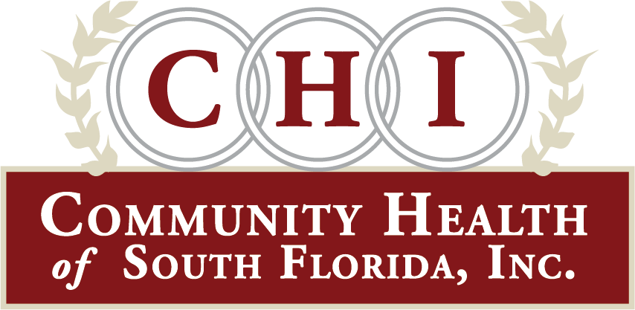
FOR IMMEDIATE RELEASE
Media Contact: Tiffani Helberg May 18, 2020
thelberg@chisouthfl.org
cell (305) 321-7541

CHI TO OFFER FREE COVID-19 TESTING IN COCONUT GROVE

Miami, Florida-Community Health of South Florida Inc. (CHI) will offer free walk-up testing for COVID-19 in the Coconut Grove area at the Frankie Shannon Rolle Neighborhood Center, 3750 S. Dixie Hwy, Miami, FL 33133 on May 29, 2020 from 10am to 2pm. Testing is for those who meet requirements and no appointment is necessary.
“CHI is committed to caring for those in the Coconut Grove, South Miami and surrounding communities.” said Brodes H. Hartley, Jr. President and CEO of CHI. “In fact, we are in the process of renovating and expanding our Coconut Grove Health Center to be able to offer even more.”
Those looking to be tested must meet the following criteria: They must have traveled to a high-risk country, have come in contact with a person who had been diagnosed with COVID-19, or have exhibited symptoms of fever, cough or shortness of breath.
CHI’s COVID-19 testing in Coconut Grove is thanks to a partnership with Miami-Dade County Commissioner Xavier Suarez, U.S. Rep. Donna Shalala, City of Miami Police Department, Macedonia Missionary Baptist Church and the Greater St. Paul AME Church.
Over the past three months, CHI has screened more than 6000 people and tested nearly 2500 residents for COVID-19 throughout South Florida. CHI was the first to offer drive through testing in Miami Dade and Monroe Counties.

CHI COVID-19 testing sites are as follows:
Frankie Shannon Rolle Neighborhood Center, 3750 S. Dixie Hwy. Miami FL 33133. May 29, 2020 from 10am to 2pm (walk up testing, no appointment necessary)

CHI Marathon Health Center 2805 Overseas Highway, Marathon, FL 33050 every Saturday from 11am to 12:30pm (Drive through testing BY APPOINTMENT ONLY.) Must be a resident of Monroe County and meet testing criteria. Call first (305)216-2107 or email KeysCovid19@chisouthfl.org

Martin Luther King/Clinica Campesina Health Center Campus 74 SW 6th Ave., Homestead, FL 33030 on Mondays and Wednesdays from 10am to 1pm. (Drive through testing. no appointment necessary)

CHI is now also offering telehealth services. Patients can see the doctor from the comfort of their own home and even have prescriptions delivered to the house. Telehealth services include primary care, pediatrics, OB/GYN, dental, behavioral health for adults and children and Urgent Care. For telehealth services call (786)272-2100.

Since 1971, CHI has been a beacon of hope providing access to high quality healthcare for all regardless of insurance status, income level or background. The non-profit federally qualified health center offers comprehensive healthcare services including primary care, pediatrics, OB/GYN, dental, urgent care, behavioral health, vision, radiology, pharmacy, transportation and more. CHI has 11 health centers and 35 school-based sites. CHI is a recipient of the Florida Governor’s Sterling Award, which is accredited by the Joint Commission and is also accredited as a patient centered medical home by the National Committee for Quality Assurance. CHI is also designated as a behavioral health medical home. In addition, CHI is home to the Brodes H. Hartley Jr., Teaching Health Center, training the next generation of doctors in primary care and psychiatry. This month, CHI is breaking ground on the first Children’s Crisis Center in southern Miami-Dade County. It will service kids with severe behavioral health problems from Monroe and Miami-Dade Counties.

# # #
For media coverage contact Tiffani Helberg, VP for Communications (305) 321-7541

